Amazon Order Processing
Zoho Books Automation Suite
N8N Automation Report
━━━━━━━━━━━━━━━━━━━━━━
n8n • Google Drive • Google Sheets • Zoho Books • Gmail

Trigger | Google Drive — File Uploaded / Updated (Google Drive Trigger)
Platform | N8N
Integrations | Google Drive, Google Sheets, Zoho Books API, Gmail
AI Model | None — rule-based data mapping and API integration
Output | Sales orders, invoices created in Zoho Books; inventory updated in real time

Project Overview
Overview
This project automates Amazon order processing and inventory management for the client, eliminating manual data entry into Zoho Books. Previously, the client exported daily Amazon order sheets and manually created orders, invoices, and updated inventory — a time-consuming and error-prone process. Using n8n, a workflow was built where the client simply uploads the order sheet to Google Drive. The system automatically reads the data, processes each order's details, and creates corresponding sales orders and invoices in Zoho Books via API. Inventory levels are also updated in real time based on order quantities. This solution reduces errors, saves time, and streamlines the entire order-to-accounting workflow.

1 | Workflow Overview — Two Automation Workflows

The solution consists of two published n8n workflows, each handling a specific type of Amazon order data:

Workflow Name | Purpose
Normal Orders → Normal Processed Sheet | Reads standard Amazon order sheet, processes each order, creates sales orders and invoices in Zoho Books, updates inventory, and writes processed data back to the sheet
Amazon Sales → Zoho SalesOrder | Handles Amazon sales data, authenticates with Zoho, loops over line items, creates or updates sales orders and invoices in Zoho Books with full item and customer mapping

2 | Automation Flow — End to End

Automation Flow
1  Sheet Uploaded to Google Drive | 2  Read & Parse Sheet Data | 3  Authenticate with Zoho | 4  Loop Over Order Rows | 5  Fetch Item & Customer | 6  Create Sales Order | 7  Create & Link Invoice | 8  Update Inventory & Sheet

Workflow 1 — Normal Orders → Normal Processed Sheet
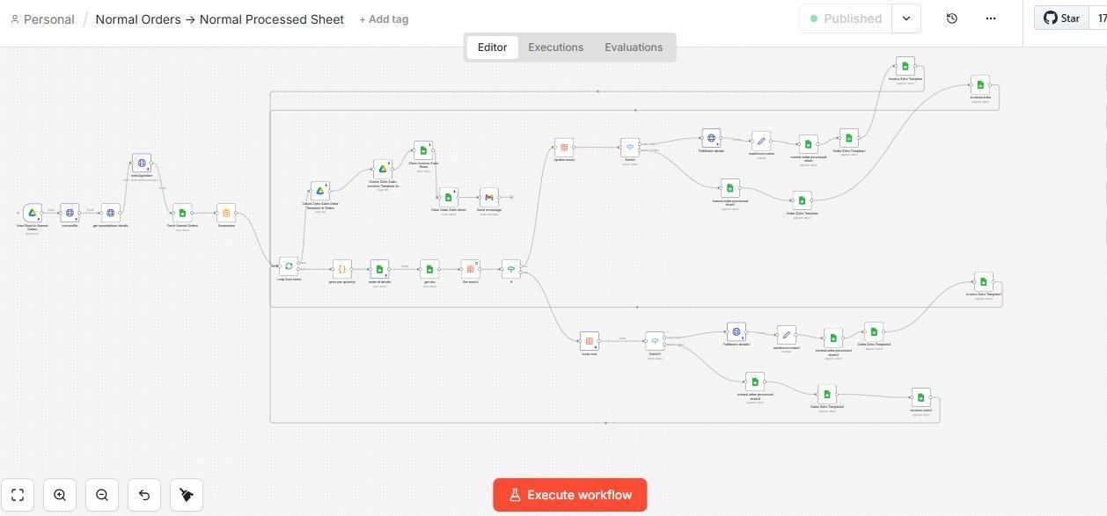
Normal Orders → Normal Processed Sheet — Full n8n Workflow

Workflow 2 — Amazon Sales → Zoho SalesOrder
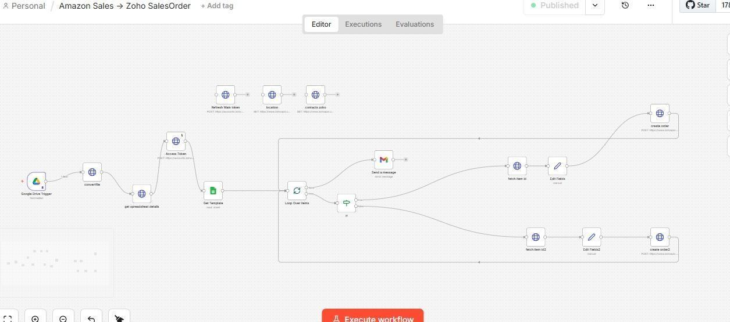
Amazon Sales → Zoho SalesOrder — n8n Workflow

Workflow Detail — Invoice & Order Creation Nodes
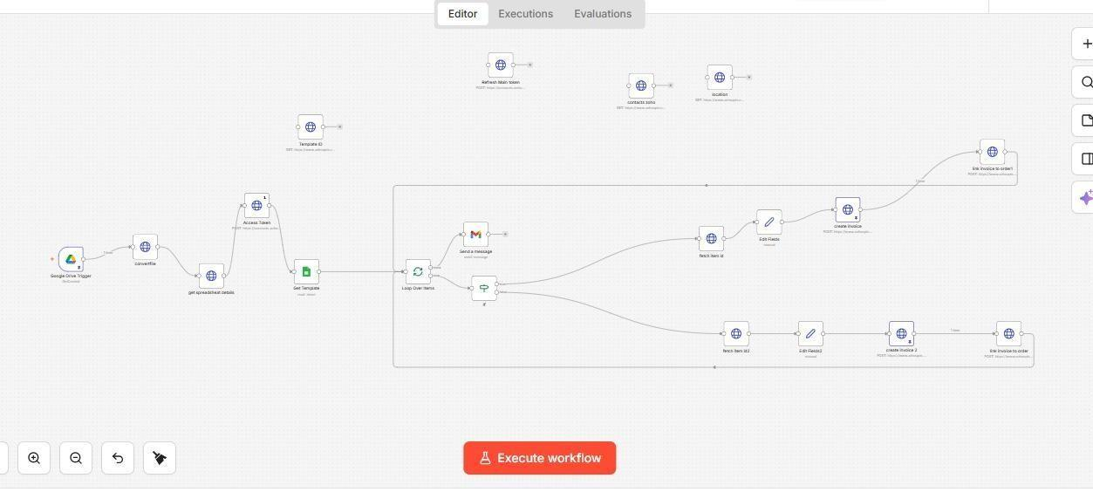
Invoice Creation & Loop Detail — n8n Workflow Nodes

3 | How It Works — Step by Step

- Step 1 — Google Drive Trigger: The client uploads the daily Amazon order export sheet to a designated Google Drive folder. n8n detects the new or updated file and immediately triggers the workflow.
- Step 2 — Read & Parse Sheet Data: The Google Sheets node reads the spreadsheet content, extracting all order rows including order ID, customer details, product SKUs, quantities, and pricing.
- Step 3 — Authenticate with Zoho Books: The workflow refreshes the Zoho OAuth access token via an HTTP POST call before making any API requests, ensuring all subsequent calls are properly authenticated.
- Step 4 — Fetch Location & Contact Data: Zoho's API is queried to retrieve the correct warehouse location and match or create the customer/contact record in Zoho Books to associate with the order.
- Step 5 — Loop Over Order Items: A Loop Over Items node iterates through each row of the order sheet. An If/filter node routes single-item and multi-item orders through separate processing branches.
- Step 6 — Fetch Item Details: For each order row, the product item is fetched from Zoho Books by SKU or item ID, retrieving the current stock level, pricing, and item metadata needed for order creation.
- Step 7 — Create Sales Order: A sales order is created in Zoho Books via API, populated with the customer, line items, quantities, and pricing extracted from the sheet. Multi-item orders use a second creation branch.
- Step 8 — Create & Link Invoice: An invoice is automatically created and linked to the corresponding sales order in Zoho Books, completing the order-to-accounting record in one automated flow.
- Step 9 — Update Inventory & Notify: Inventory levels in Zoho Books are adjusted based on ordered quantities. Gmail sends a confirmation or error notification email upon workflow completion.

4 | Zoho Books Records Created & Updated

Zoho Record Type | How It Is Handled
Sales Order | Created for each Amazon order with customer, item, and quantity details mapped from the sheet
Invoice | Generated and linked to the sales order automatically after order creation
Inventory Update | Item stock levels in Zoho Books adjusted in real time based on ordered quantities
Customer Record | Customer/contact data fetched or matched in Zoho before order creation to ensure correct association

5 | Challenges & How the Workflow Addresses Them

- Zoho Books API requires OAuth authentication — tokens expire and must be refreshed: Before any API call is made, the workflow posts to Zoho's token endpoint to refresh the access token. This ensures all downstream API calls use a valid token and the workflow never fails due to an expired session.
- Amazon order sheets contain both single-item and multi-item orders in the same file: An If node checks whether each row represents a single or multiple line items and routes them through dedicated processing branches — each with its own item fetch, field mapping, and order/invoice creation nodes.
- Manual data entry into Zoho was slow, inconsistent, and error-prone: The workflow maps all fields programmatically from the sheet to the Zoho API payload, eliminating human transcription. Each field is explicitly mapped, ensuring consistent, accurate data in every order and invoice created.
- Inventory must stay in sync with order quantities across multiple daily batches: After each order is created, the corresponding item's inventory level in Zoho Books is updated via API in real time, ensuring stock figures are always accurate without any manual stock adjustment.
- Invoices must be linked to their parent sales orders in Zoho: After each sales order is created and its ID is returned by the API, the workflow immediately posts a second API call to create the invoice and link it to that specific order ID — keeping the accounting trail intact.

6 | Tools & Integrations

Tool / Service | Role in Workflow
Google Drive Trigger | Detects when the Amazon order sheet is uploaded or updated by the client
Google Sheets Node | Reads order data row by row from the uploaded spreadsheet
Zoho Books API (OAuth) | Creates sales orders, invoices, and updates inventory via authenticated REST API calls
Gmail | Sends email notifications on workflow completion or errors
Loop Over Items | Iterates through each order row to process them individually and handle both single-item and multi-item orders
HTTP Request / Webhook | Handles Zoho API authentication (token refresh) and direct API endpoint calls for order and invoice creation
If / Filter Node | Conditional routing — handles differences between single-item and multi-item order rows in the same sheet

System Architecture Summary

INPUT SOURCE | n8n AUTOMATION | OUTPUT
• Amazon Order Export Sheet  • Uploaded to Google Drive  • Daily by Client | • Google Drive Trigger  • Sheet Parsing  • Zoho OAuth Token Refresh  • Loop & Item Routing  • Sales Order & Invoice API | • Sales Orders in Zoho Books  • Invoices Linked to Orders  • Inventory Updated in Real Time  • Gmail Completion Notification

End of Document

